Preflight Challenge: Student Research Guide
Name:_____________________

Thinking ahead: What words come to mind when you hear (name of professional’s job)?
Conduct some brief online research about the job of a (professional’s job).
What are five things a (job name) does? What experience and skills do you need?

What seem like the best parts of the job? The worst parts?

What are three questions you have for our speaker?
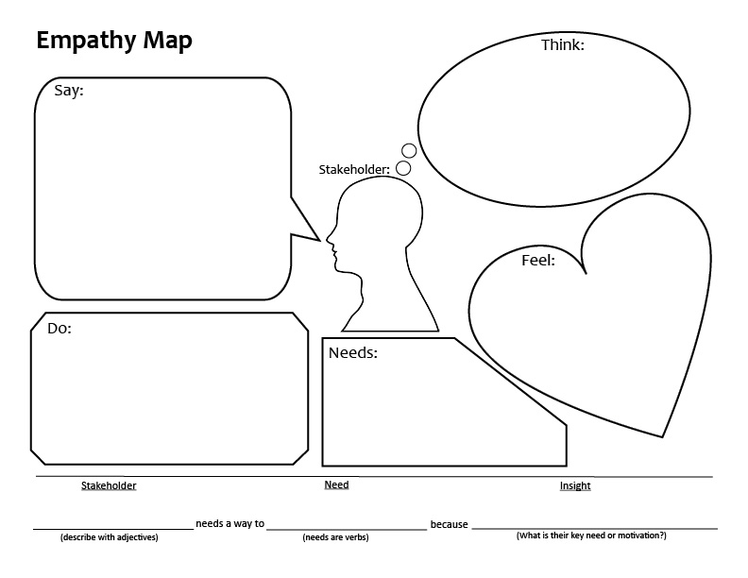
Student Prototyping Guide
Describe your idea:

Who is the user for your idea? Describe them in detail:

What medium will you use to show your idea? (e.g. poster, physical model, skit, slideshow)

How will you test your idea? When? With whom?

What are you unsure about? What questions do you still need to answer?

How can you break up your project into smaller tasks?
Task | Materials | Due Date
Remember: Prototyping is a cycle. Your goal is to model your idea, then get it out into the world.
Failure = Learning

